1. Open this link to the excel file: [Edgar API Links.xlsx](https://1drv.ms/x/c/10c3548d8c06acf2/EdFoiryAxRpLlKc9AyZEol4Bu4AF9801db3fIpXqkPtW1w?e=nj93Fg)
2. Find the next blank sheet (should be around the 100 sheet mark)
3. Type the name of the company in B1
4. Go to this link: [SEC.gov | Search Filings](https://www.sec.gov/search-filings)
5. Type in the company name in the search bar

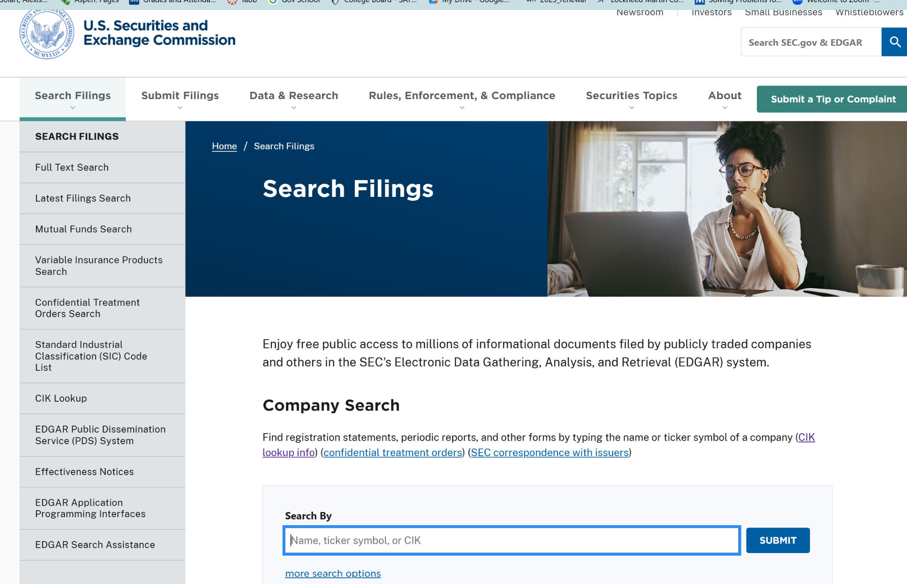

1. Click on the company name (if there’s multiple it should be the first one)
2. Click on the button that says “10k reports”
   1. Then click “View all 10ks and 10qs”

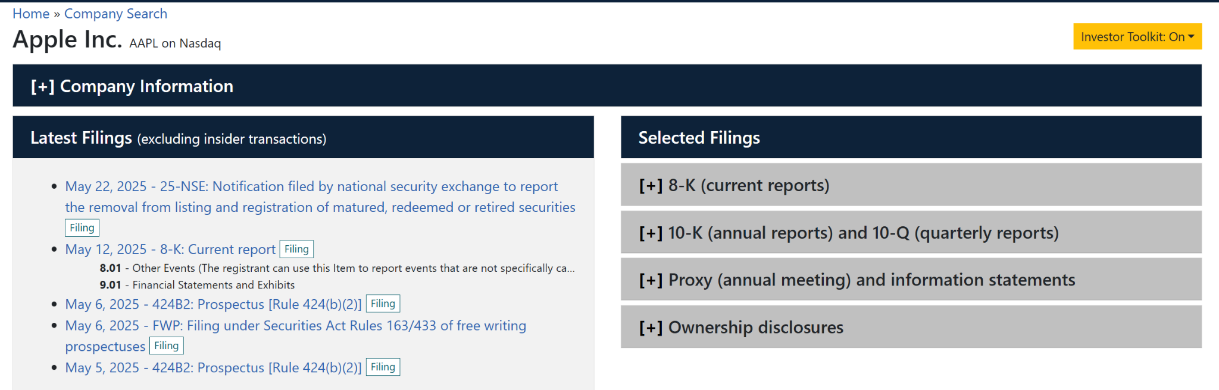

1. Delete the year listed at the top (ex. 2014-10-20)

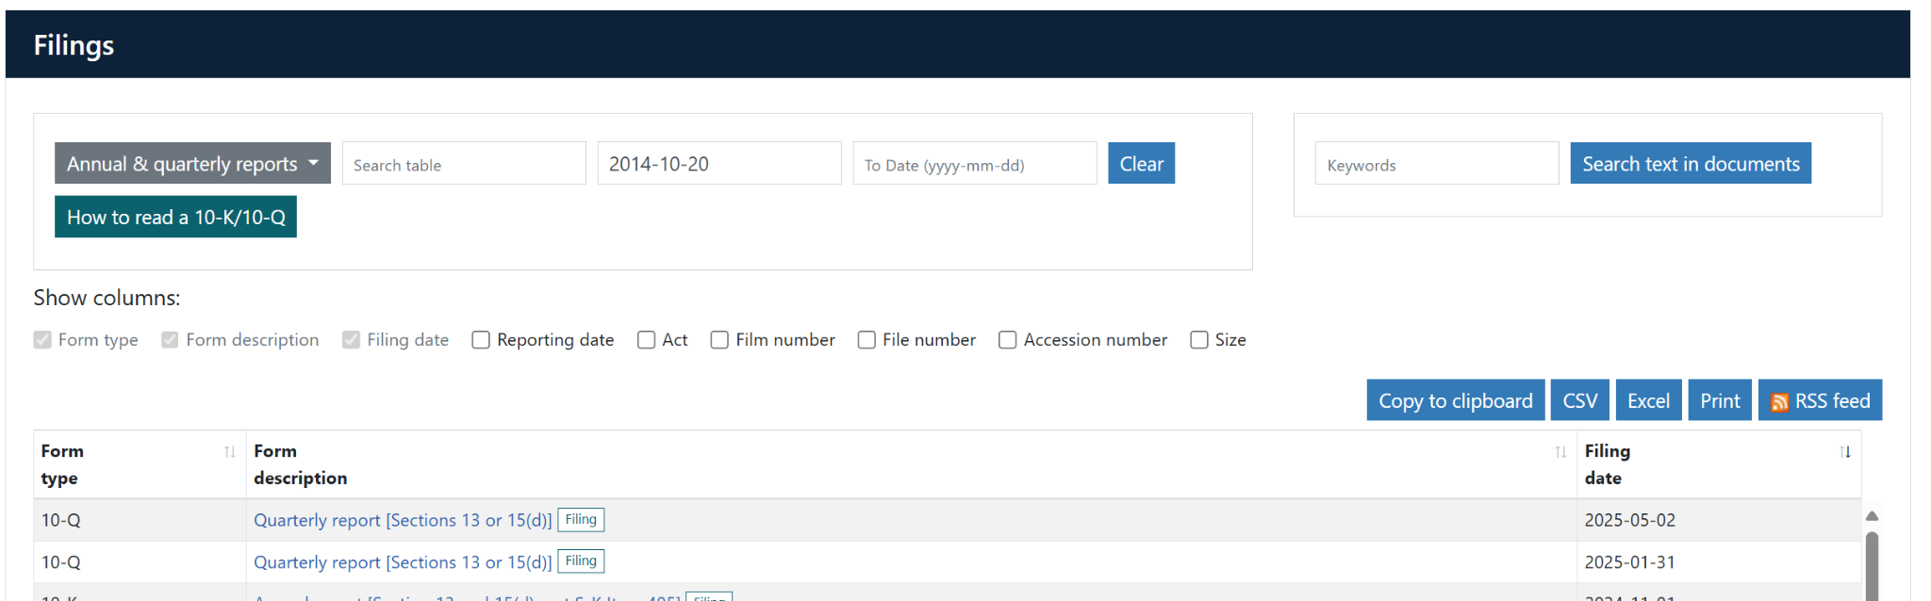

1. Click on the 10k link for each year
   1. The newer 10k forms will take you to this screen:
      1. Click on menu (top left)
      2. Click on “open in html”
      3. Copy that webpage’s URL and paste in the row with the matching year

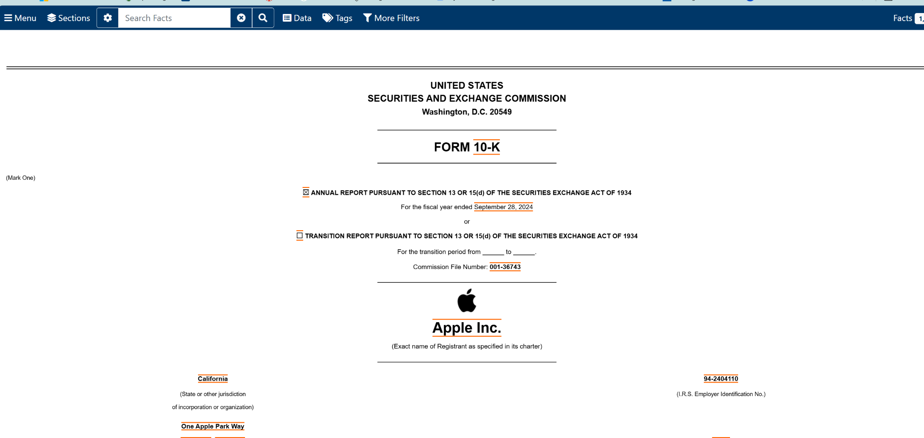

* 1. The older 10k forms will take you straight to this:
     1. Copy and paste the URL into the excel
        1. (Basically skips step a.)

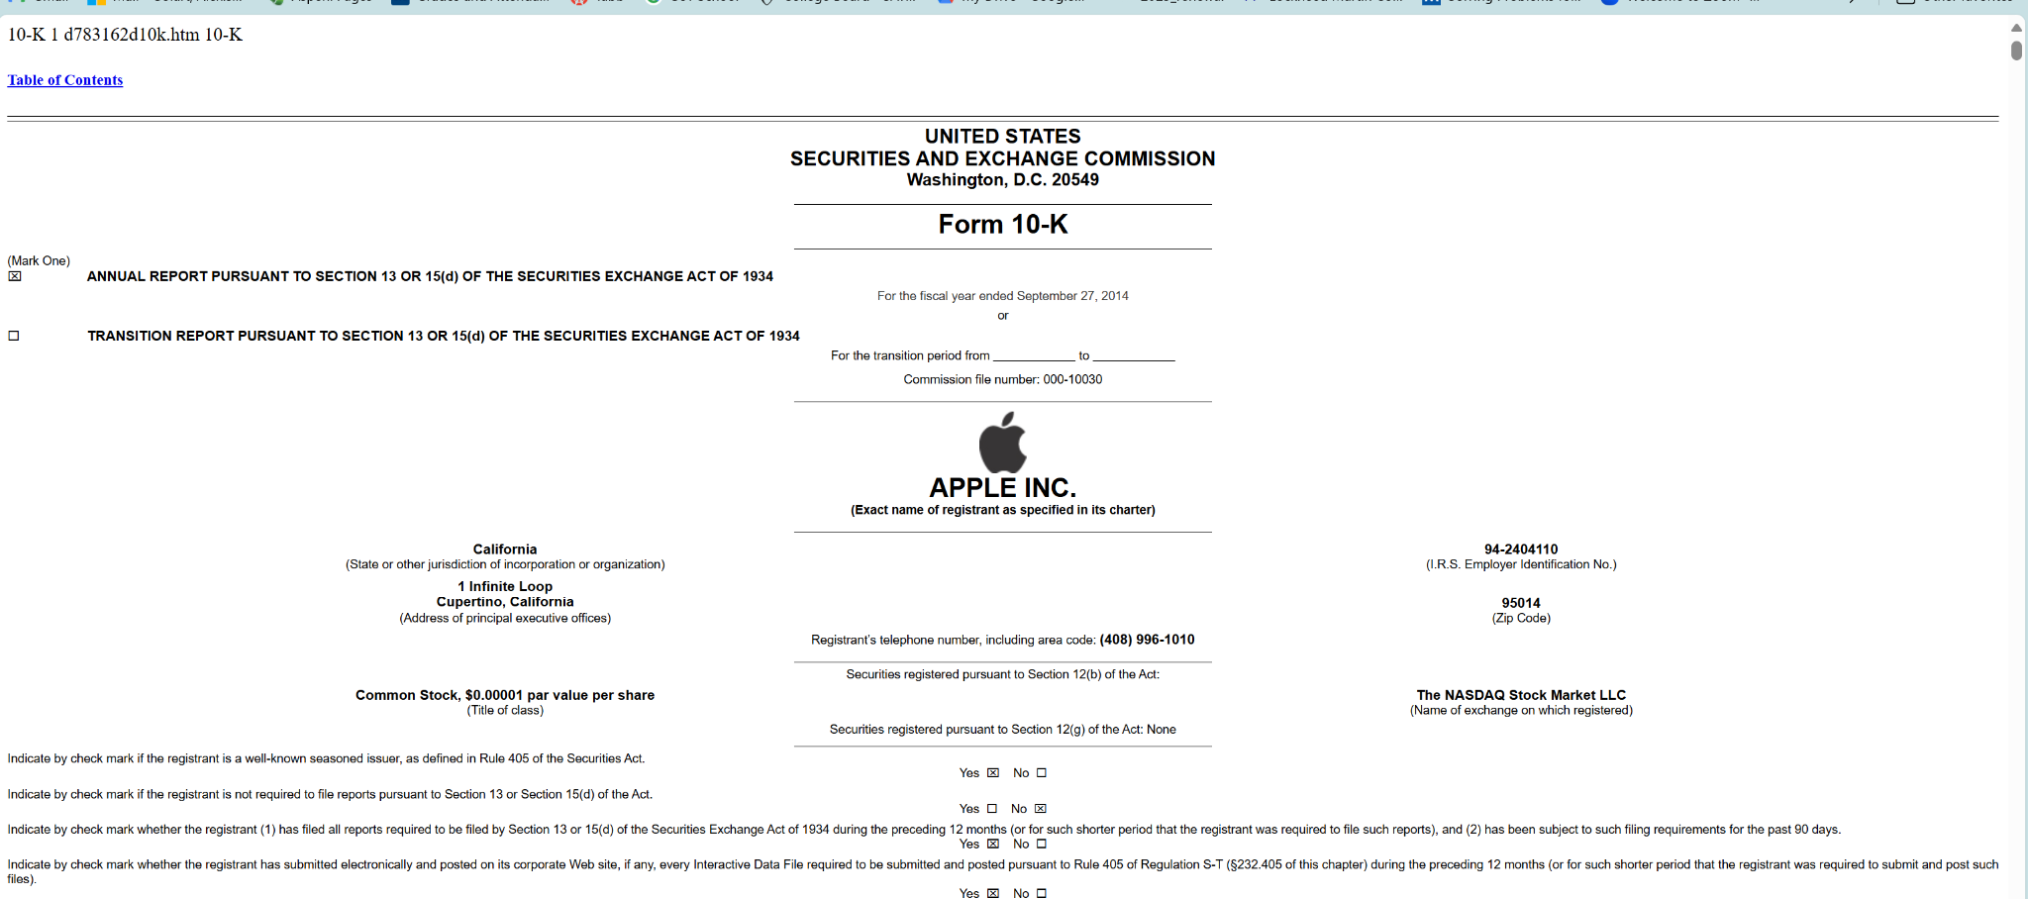

1. Repeat with every year until you run out of years!
2. Delete any year numbers in column a that we don’t have links for
3. Congrats: you finished the company!